

CSM3023 WEB BASED APPLICATION DEVELOPMENT (K1)

**BACHELOR OF COMPUTER SCIENCE (MOBILE COMPUTING) WITH HONORS**

**SEMESTER 2 2023/2024**

LAB 2 – Servlet: Data Sharing and Database Management

**Prepared for:**

DR. MOHAMAD NOR HASSAN

**Prepared by:**

MUHAMMAD HARITH BIN ZULKIFLI (S67335)

Task 1:Data Sharing in Servlet login.html

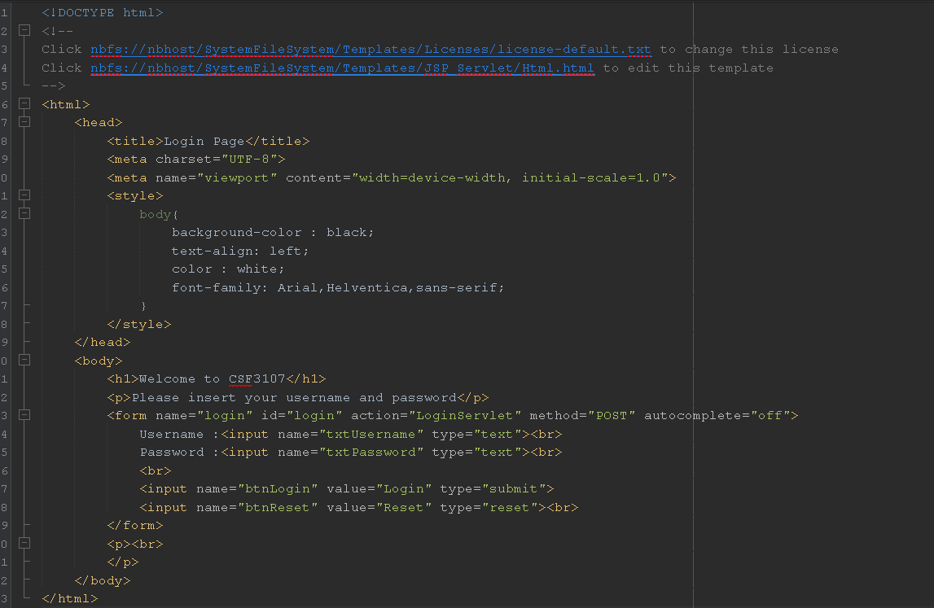

LoginServlet.java

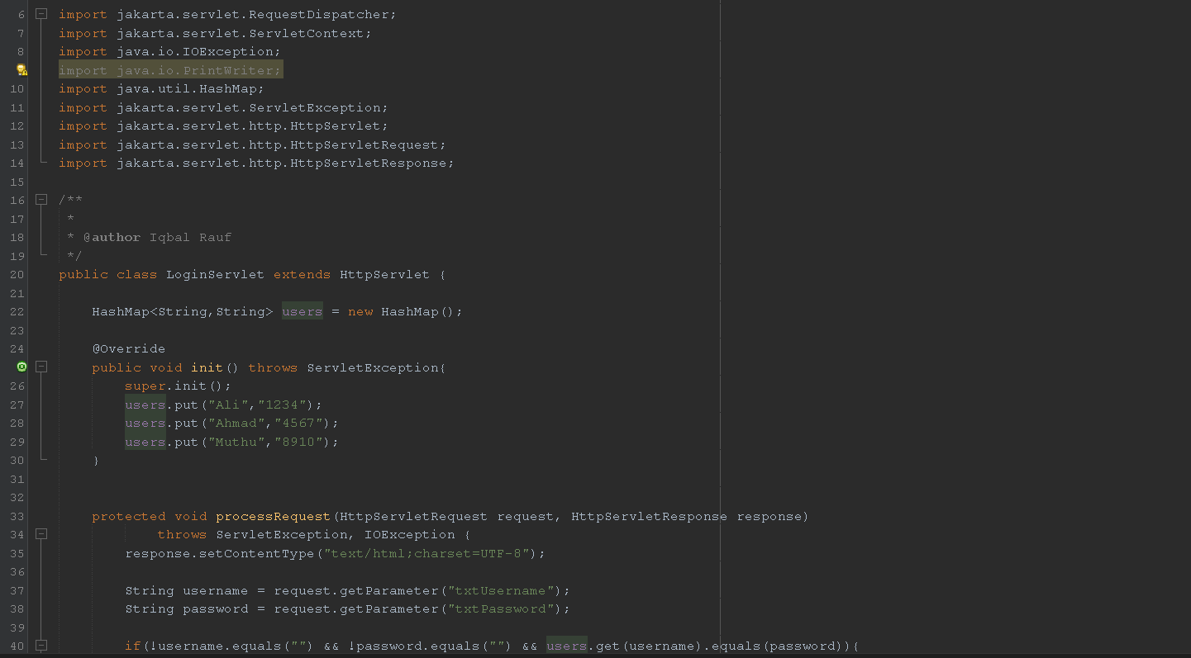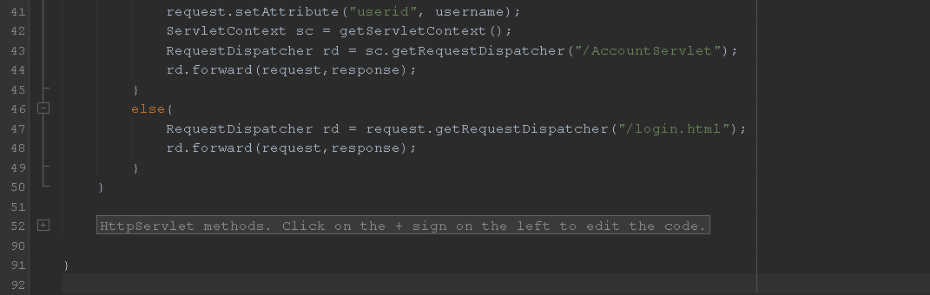

AccountServlet.java

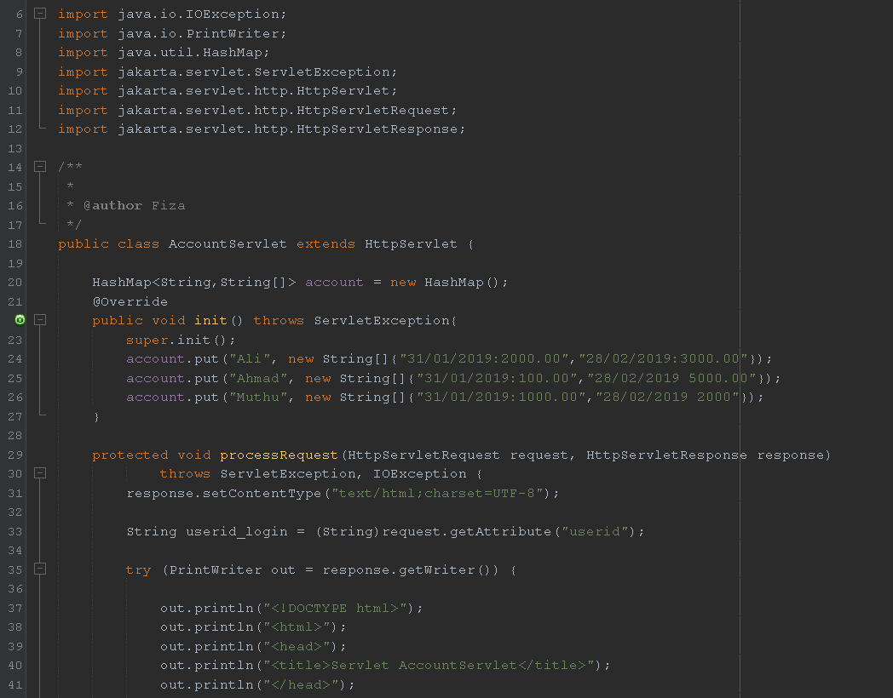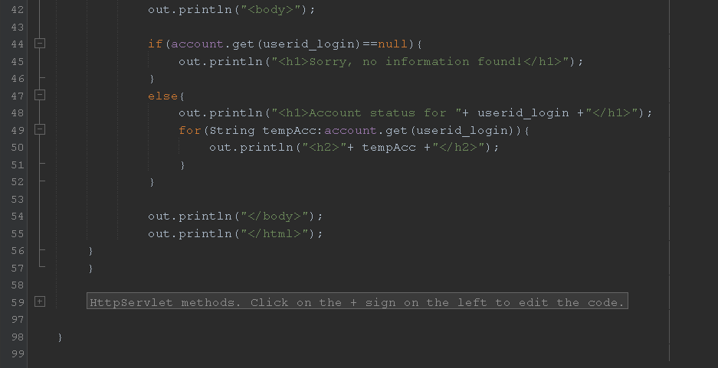

Output:

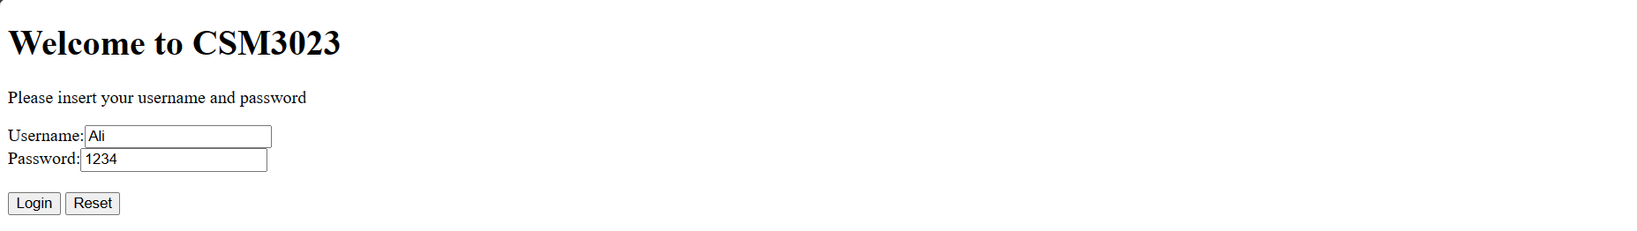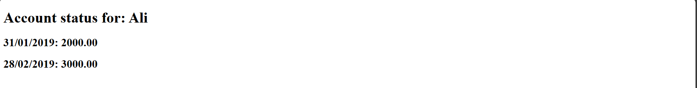

Reflections:

1. What have you learnt form this exercise?

I have learnt how the data sharing process works by using servlet.

1. What are the common methods used in Java Servlet? doGet() and doPost()

Task 2:Creating a table in MySQL database

Output:

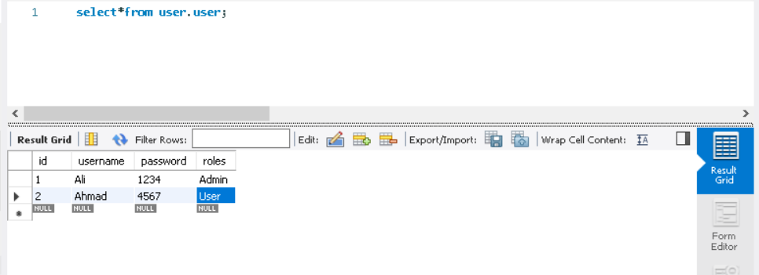

Task 3:Setting the Environment of Web Application for Database Connection

Output:

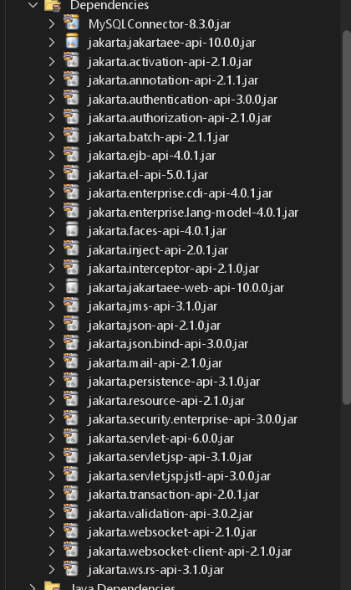

Task 4: Using Servlets for Database CRUD Operations

Index.html

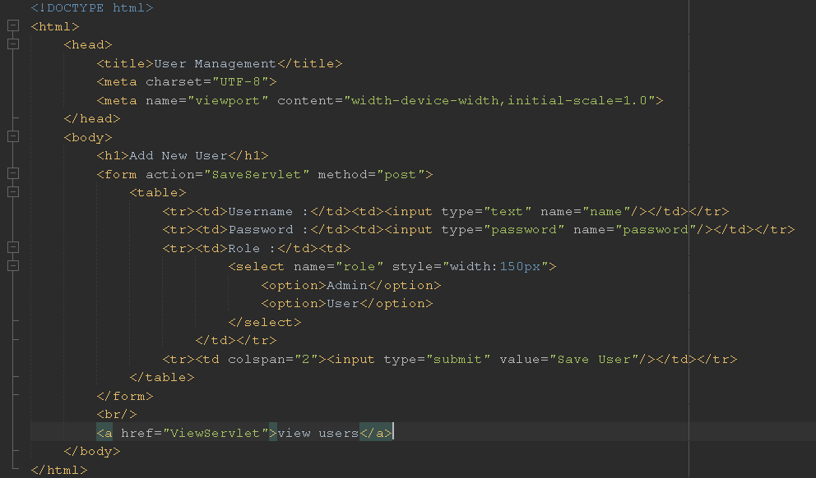

User.java

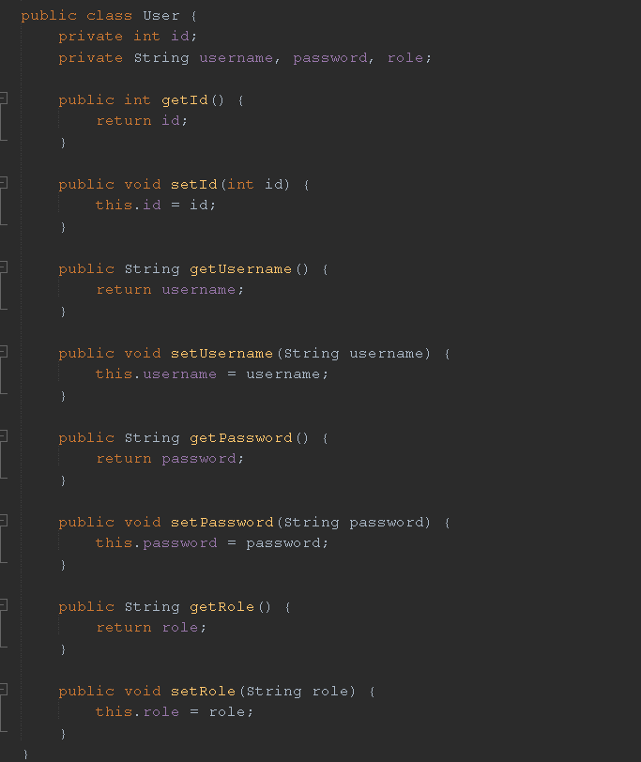

UserDao.java

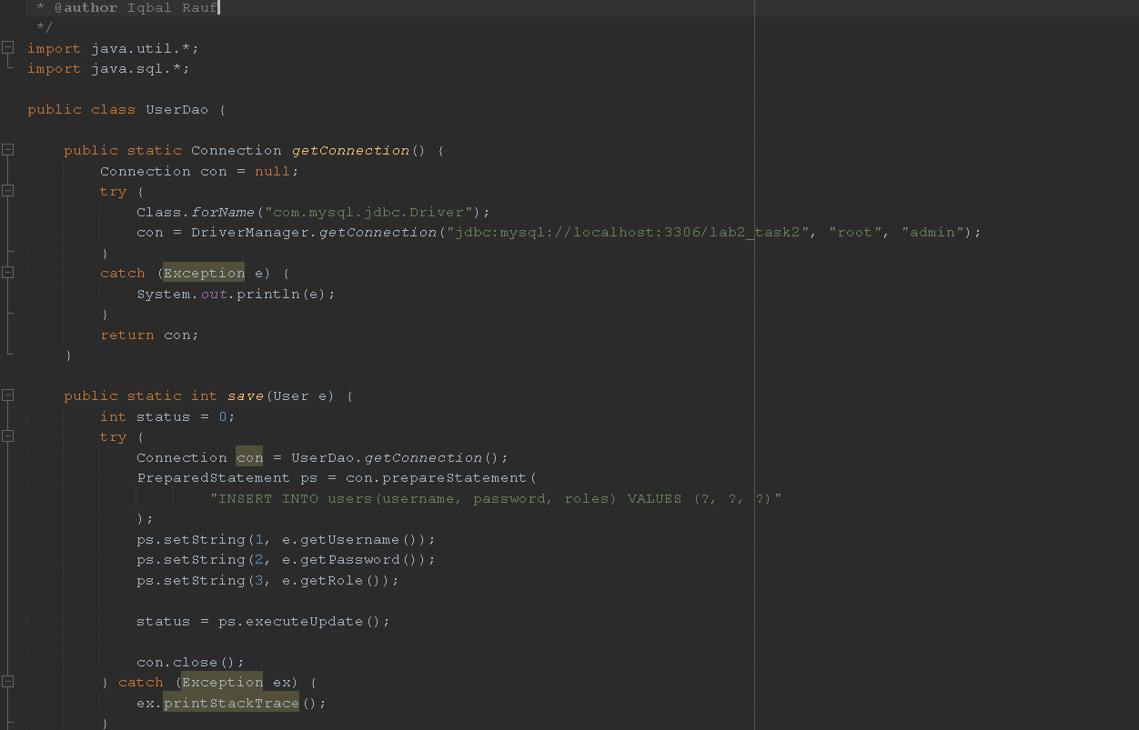

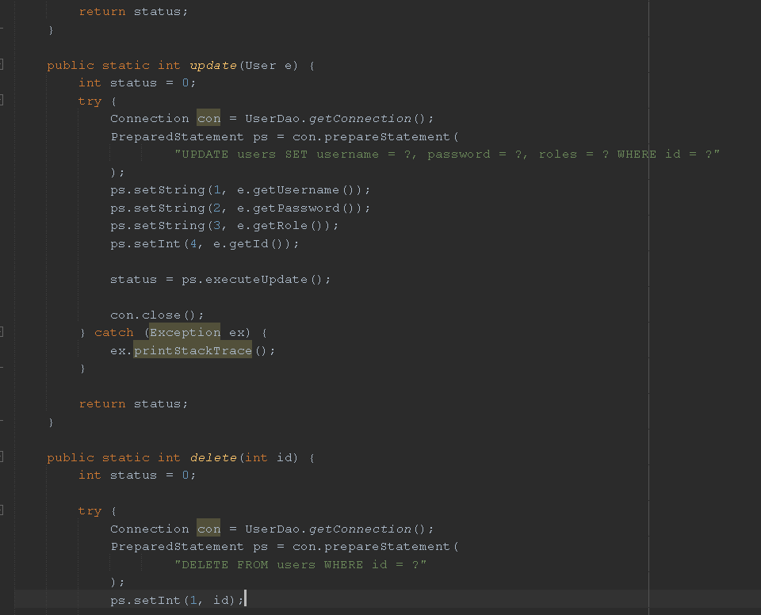

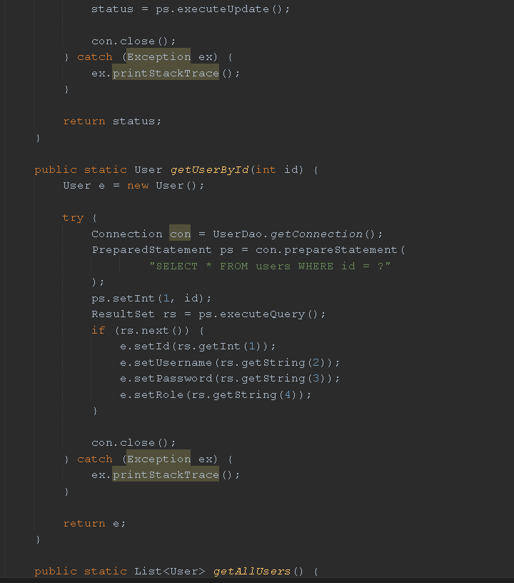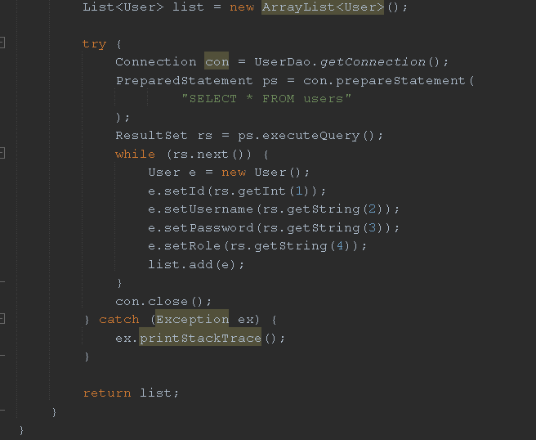

SaveServlet.java

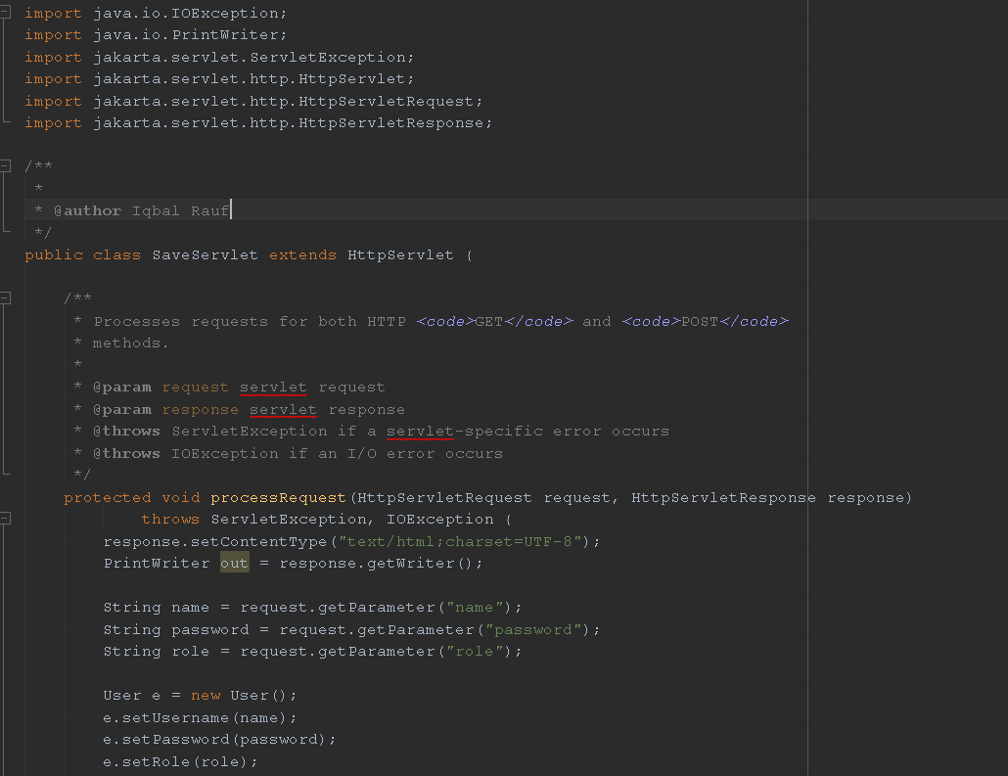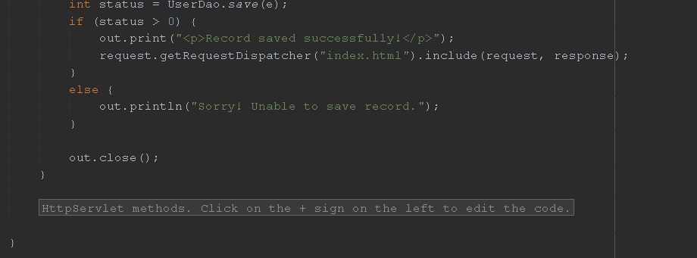

ViewServlet.java

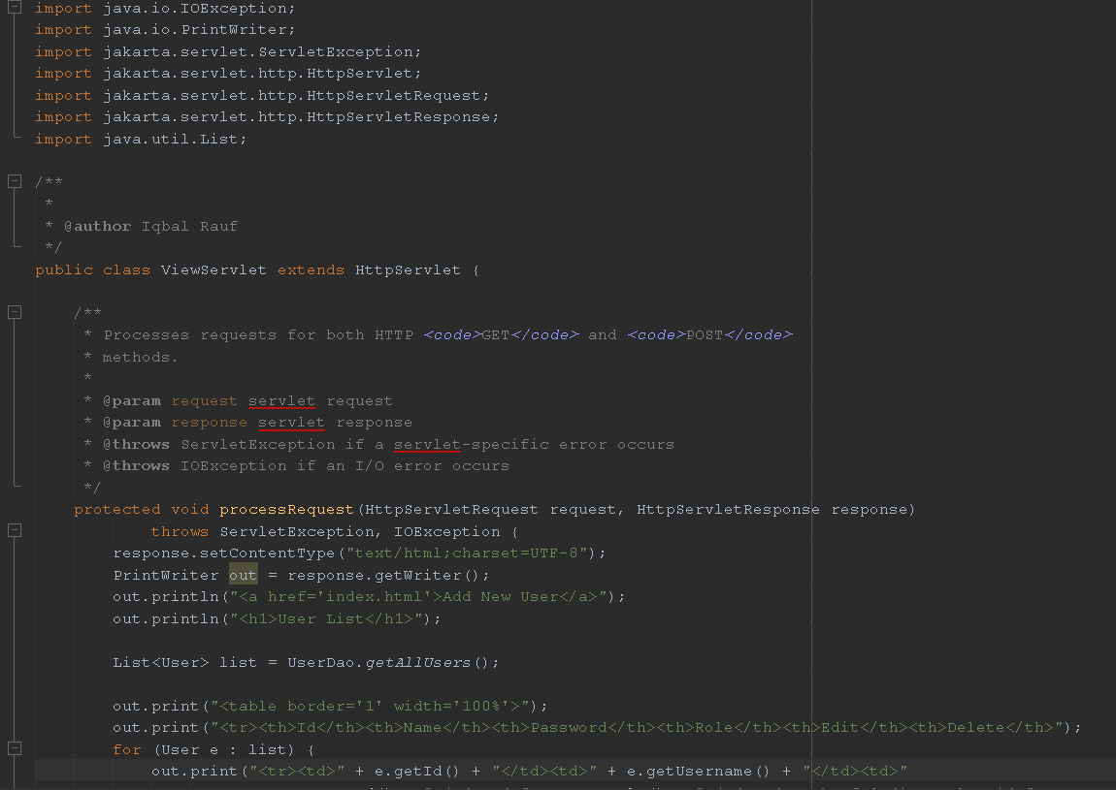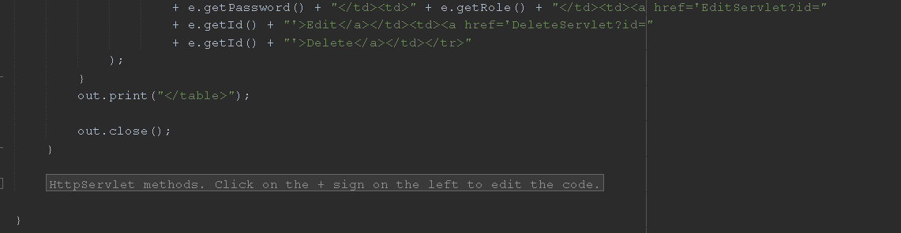

EditServlet.java

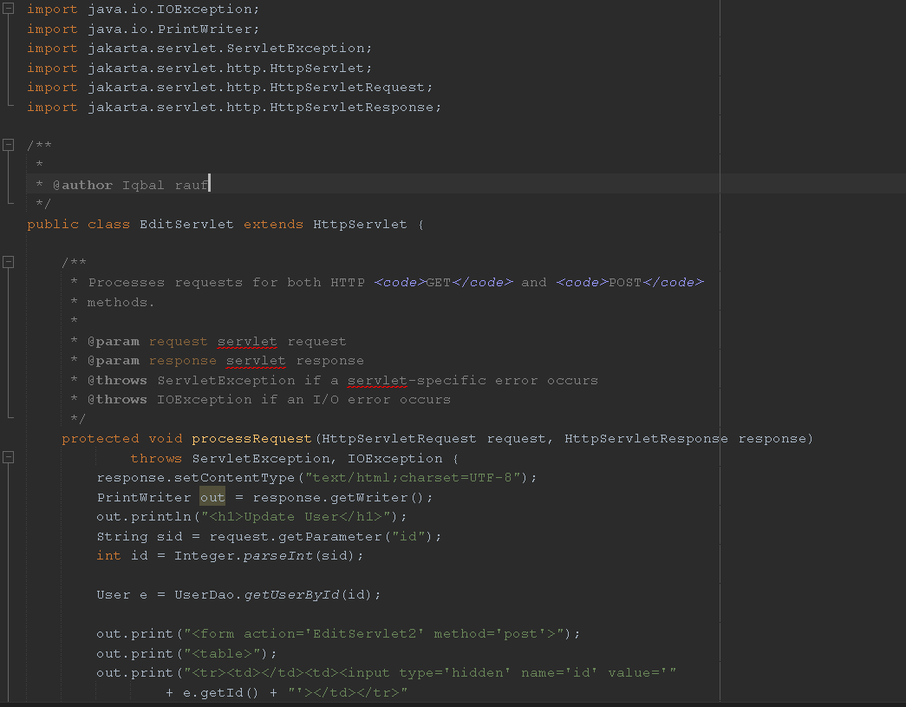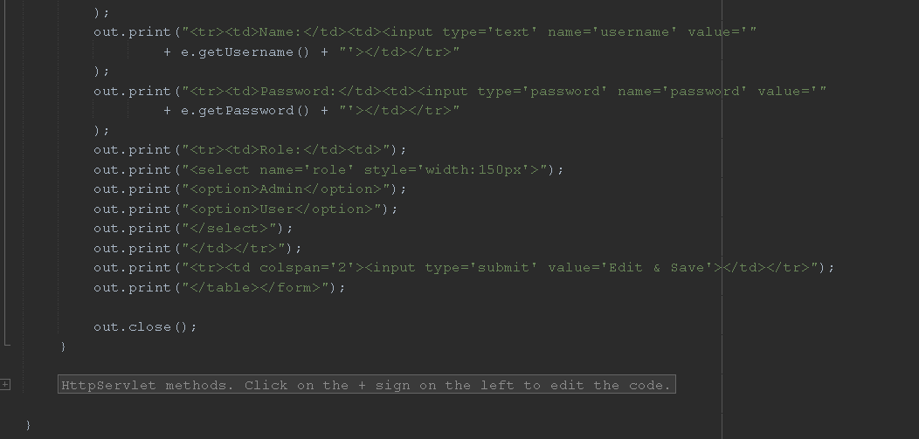

EditServlet2.java

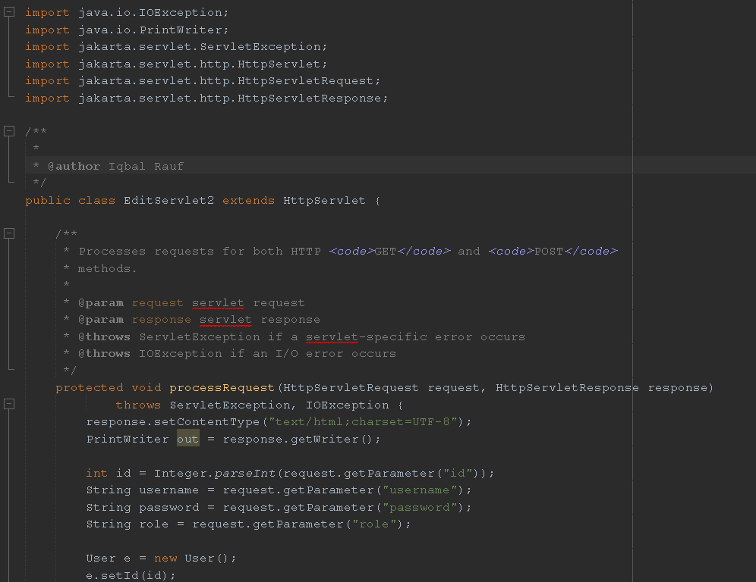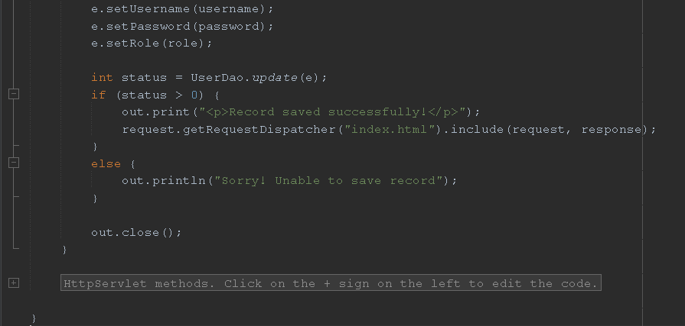

DeleteServlet.java

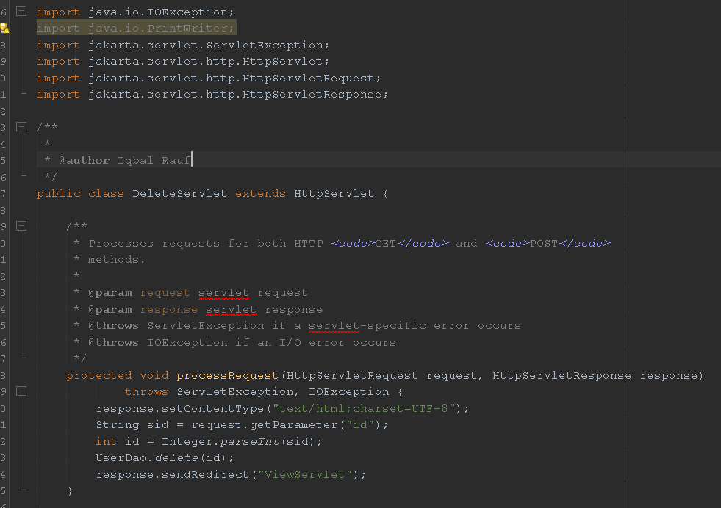

Output:

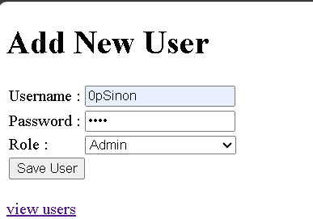

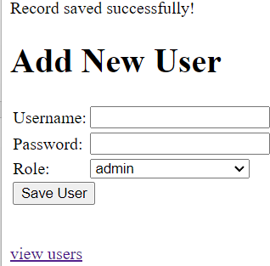

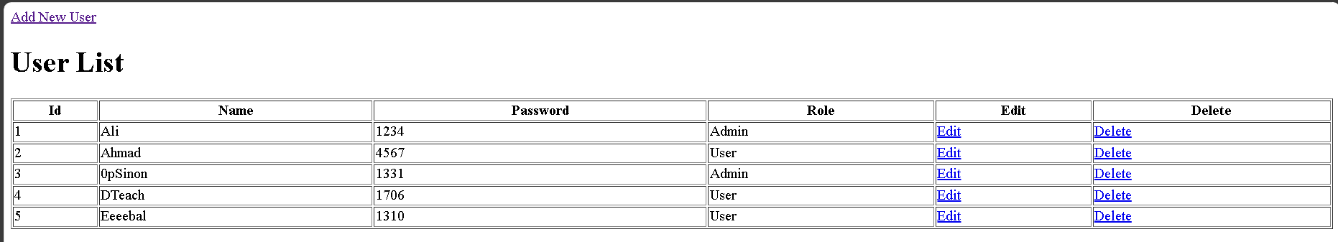

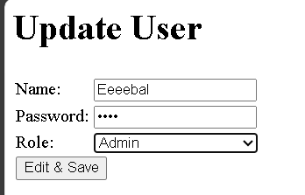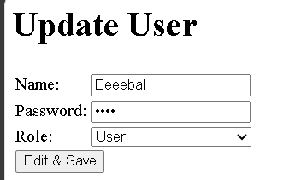

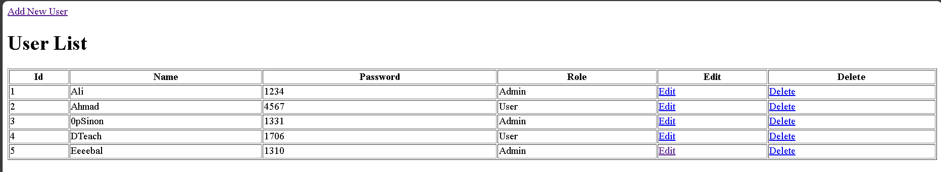

Reflections:

1. What is the name of the Java Library that you need to import before coding the web application with database operations?

JDBC (Java Database Connectivity).It provides a set of classes and interfaces for accessing and manipulating relational databases from a Java program.It also allows Java applications to connect to a database and perform CRUD process by sending SQL queries to database.

1. Which folder keeps the web.xml file? Copy the contents of the file and explain in brief the tags included such as <servlet-name><servlet- class>

<servlet-mapping>. etc.

The web.xml file is kept inside WEB-INF folder.

<?xml version="1.0" encoding="UTF-8"?>

<web-app version="6.0" xmlns="https://jakarta.ee/xml/ns/jakartaee" xmlns:xsi="<http://www.w3.org/2001/XMLSchema-instance>" xsi:schemaLocation="https://jakarta.ee/xml/ns/jakartaee https://jakarta.ee/xml/ns/jakartaee/web-app_6_0.xsd">

<servlet>

<servlet-name>SaveServlet</servlet-name>

<servlet-class>SaveServlet</servlet-class>

</servlet>

<servlet>

<servlet-name>ViewServlet</servlet-name>

<servlet-class>ViewServlet</servlet-class>

</servlet>

<servlet>

<servlet-name>EditServlet</servlet-name>

<servlet-class>EditServlet</servlet-class>

</servlet>

<servlet>

<servlet-name>EditServlet2</servlet-name>

<servlet-class>EditServlet2</servlet-class>

</servlet>

<servlet>

<servlet-name>DeleteServlet</servlet-name>

<servlet-class>DeleteServlet</servlet-class>

</servlet>

<servlet-mapping>

<servlet-name>SaveServlet</servlet-name>

<url-pattern>/SaveServlet</url-pattern>

</servlet-mapping>

<servlet-mapping>

<servlet-name>ViewServlet</servlet-name>

<url-pattern>/ViewServlet</url-pattern>

</servlet-mapping>

<servlet-mapping>

<servlet-name>EditServlet</servlet-name>

<url-pattern>/EditServlet</url-pattern>

</servlet-mapping>

<servlet-mapping>

<servlet-name>EditServlet2</servlet-name>

<url-pattern>/EditServlet2</url-pattern>

</servlet-mapping>

<servlet-mapping>

<servlet-name>DeleteServlet</servlet-name>

<url-pattern>/DeleteServlet</url-pattern>

</servlet-mapping>

<session-config>

<session-timeout> 30

</session-timeout>

</session-config>

</web-app>

<servlet-name> specifies a unique name for the servlet configuration.

<servlet-class> specifies the fully permissioned class name of the implementation.

<servlet-mapping> maps a servlet to a URL pattern. It defines the URLs that invoke the servlet.

<url-pattern> specifies the URL pattern to which the servlet is mapped.

1. Define the usage of Data Access Object (DAO) servlet. How it ease thebusiness process in your servlet-based web application?

DAO servlet is a design pattern used to separate the data access logic from the business logic of a servlet-based web application.DAO involves creating a separate class or set of classes responsible for interacting with the database, querying data, and perform database CRUD operations.By using a DAO servlet, the business logic in servlets can focus on handling user requests, processing data, and generating responses, while the data access logic is encapsulated within the DAO classes, improving the overall organization and clarity of the application architecture.